HRTF 3D
Version 1.1.0

Welcome

Thank you for downloading this fine plug-in from the Delphi ASIO & VST Project. The HRTF 3D plugin convolves the incoming audio with the selected head related transfer function to create the impression of a sound coming from that direction.
In order to get the most out of the HRTF 3D, please spend a few moments reading this brief manual.

License

HRTF 3D has a very simple license:

- HRTF 3D is freeware. This means that you are free to use this plugin in any context. Also you are free to share it on a personal base (ie. give it to friends). However, only the entire unaltered archive, including this document, may be shared. Public redistribution is only allowed on request.
- Copyright of the code and the pre-compiled plug-in remain property of the Delphi ASIO & VST Project and namely Christian-W. Budde.
- This plug-in is provided at no cost; therefore the author Christian-W. Budde assume no responsibility for any negative effects that may occur to the end user or the equipment used to run the plug-in.
- Magazine editors are welcome to include the plug-in on cover mount discs or similar media; However, it is mandatory to inform the author Christian-W. Budde about this. A copy of the publication is always appreciated, but not expected.

Controls

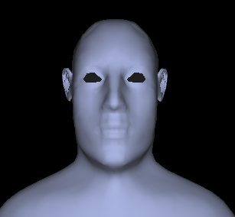
Controlling this plugin is very easy. Just move the head in the desired position to the source. By holding [Ctrl] and [Alt] you can keep either the azimuth or polar direction unchanged.

Feedback / Bug Reports
We are always eager to hear feedback or have bugs reported.

Version History

    - First release!

Credits
• Programming: Christian W. Budde
• Documentation based on a template by Greg Pettit

VST name and technology © Steinberg GmbH
The VST logo is a trademark of Steinberg GmbH

